Project Design Phase-II
Data Flow Diagram & User Stories

Date | 3 July 2026
Team ID
Project Name | RK-HEALTH
Maximum Marks | 4 Marks

Data Flow Diagrams:
A Data Flow Diagram (DFD) is a traditional visual representation of the information flows within a system. A neat and clear DFD can depict the right amount of the system requirement graphically. It shows how data enters and leaves the system, what changes the information, and where data is stored.
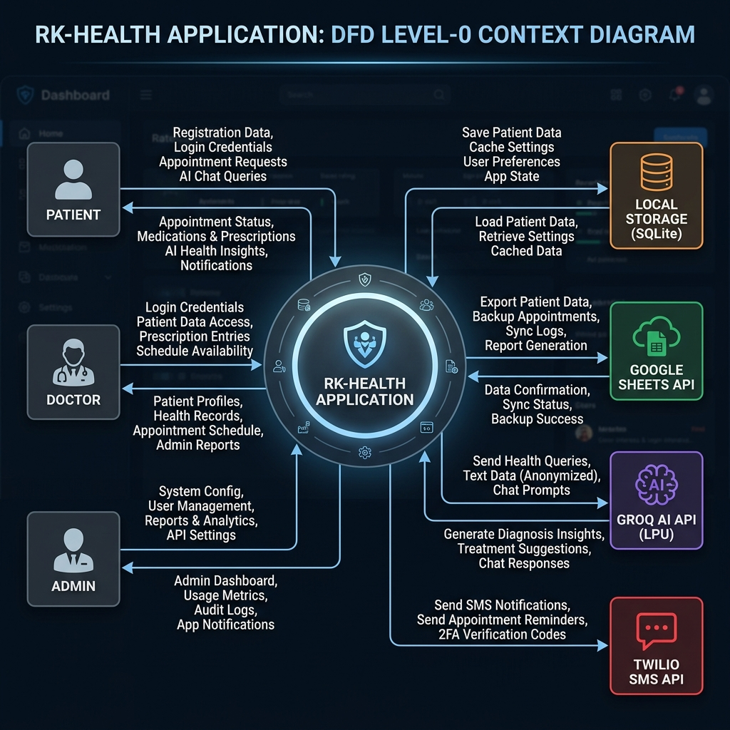
Figure 2: Data Flow Diagram (Level 0 Context Diagram) of RK-HEALTH

User Stories
Use the below template to list all the user stories for the product.
User Type | Functional Requirement (Epic) | User Story Number | User Story / Task | Acceptance criteria | Priority | Release
Patient (Mobile/Web) | Authentication | US-01 | As a patient, I can register and login to access my health dashboard | I can see my dashboard with appointments, medications, and summaries | High | Sprint-1
Patient | Authentication | US-02 | As a patient, I can switch between patient and doctor login tabs | I am shown appropriate UI based on my role | High | Sprint-1
Patient | Appointments | US-03 | As a patient, I can schedule a new appointment by selecting a doctor, date, and time | The appointment appears in my list and an AI summary is generated | High | Sprint-2
Patient | Appointments | US-04 | As a patient, I can add my appointments to Google Calendar with one click | A calendar link opens with pre-filled event details | Medium | Sprint-2
Patient | Medications | US-05 | As a patient, I can add medications and set timing reminders | Medicine appears with active status and timing badge | High | Sprint-2
Patient | Medications | US-06 | As a patient, I can mark medications as completed | Medication status changes and compliance tracking updates | Medium | Sprint-2
Patient | AI Assistant | US-07 | As a patient, I can describe my symptoms and get a specialist recommendation | AI suggests relevant specialist, urgency level, and next steps | High | Sprint-3
Patient | AI Assistant | US-08 | As a patient, I can request a personalized diet plan | AI generates meal plan with breakfast, lunch, dinner, and snacks | High | Sprint-3
Patient | Reports | US-09 | As a patient, I can view and print a comprehensive health report | Report shows all appointments, meds, compliance, and AI summaries | Medium | Sprint-3
Doctor | Dashboard | US-10 | As a doctor, I can login and see my daily appointment schedule | Doctor dashboard shows today's patients, upcoming appointments, and stats | High | Sprint-4
Doctor | AI Assistant | US-11 | As a doctor, I can use the AI assistant for medical reference | AI responds with relevant medical information (within appropriate boundaries) | Medium | Sprint-3
Admin | Doctor Management | US-12 | As an admin, I can add, edit, and remove doctors from the directory | Doctor list updates and new doctors appear in appointment dropdown | High | Sprint-4
Admin | User Management | US-13 | As an admin, I can create doctor accounts and promote users to admin | New accounts are functional immediately with appropriate role permissions | High | Sprint-4
All Users | Notifications | US-14 | As any user, I receive in-app reminders 5 minutes before appointments | A toast notification appears and browser notification fires | Medium | Sprint-4
All Users | UI | US-15 | As any user, I can toggle between light and dark themes | All UI elements properly render in the selected theme | Low | Sprint-4

DATA FLOW DIAGRAM — LEVEL 0 (Context Diagram):
EXTERNAL ENTITIES:
• Patient — Primary user who manages appointments, medications, and queries AI
• Doctor — Secondary user who views appointments and uses AI assistant
• Admin — Power user who manages doctors and user accounts
PROCESSES:
P1: Authentication (Register, Login, Role-based access)
P2: Dashboard Management (Summary cards, timeline, notifications)
P3: Appointment Management (CRUD, search, filter, calendar integration)
P4: Medication Management (CRUD, status toggle, timing, reminders)
P5: AI Chatbot (General Q&A, symptom analysis, diet plans)
P6: Report Generation (Aggregate data, generate summaries, export)
P7: Doctor Directory (Browse, filter, manage)
DATA STORES:
D1: localStorage (Appointments, Medications, Summaries, Chat history, Users, Doctors)
D2: Groq AI API (External — LLM inference)
D3: Google Sheets (via Apps Script — cloud persistence)
D4: Twilio API (External — SMS notifications)
DATA FLOWS:
• Patient ↔ P2: Dashboard data (appt count, med count, timeline)
• Patient → P3: Appointment details → D1: Stored appointments
• Patient → P4: Medication details → D1: Stored medications
• Patient ↔ P5: Chat messages → D2: AI responses
• P3 → Patient: Calendar link (Google Calendar URL)
• Doctor → P1: Credentials → Role-based dashboard
• Admin → P7: Doctor CRUD → D1: Updated doctor list

